MEG Connections

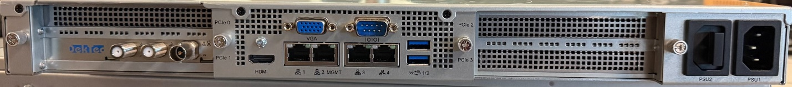

RF INPUT-1

SES-18 H

Multicast

enpS07

Management

enp6S0

Not Used

Power

ASI/SDI BNC

Out

* Connect RF to RF Input-1 (SES-18 H)
* Connect Ethernet to Interface-3 for management
* Connect the type of output you ordered to a device which will validate signal
  + For ASI – Connect to ASI/SDI BNC
  + For SDI – Connect to ASI/SDI BNC
  + For TSoip – Connect to Multicast interface